Explain the below linux commands with an example. Share the screenshot of each

command with the output :

1. **pwd**

prints full path name of current working directory

syntax : pwd

: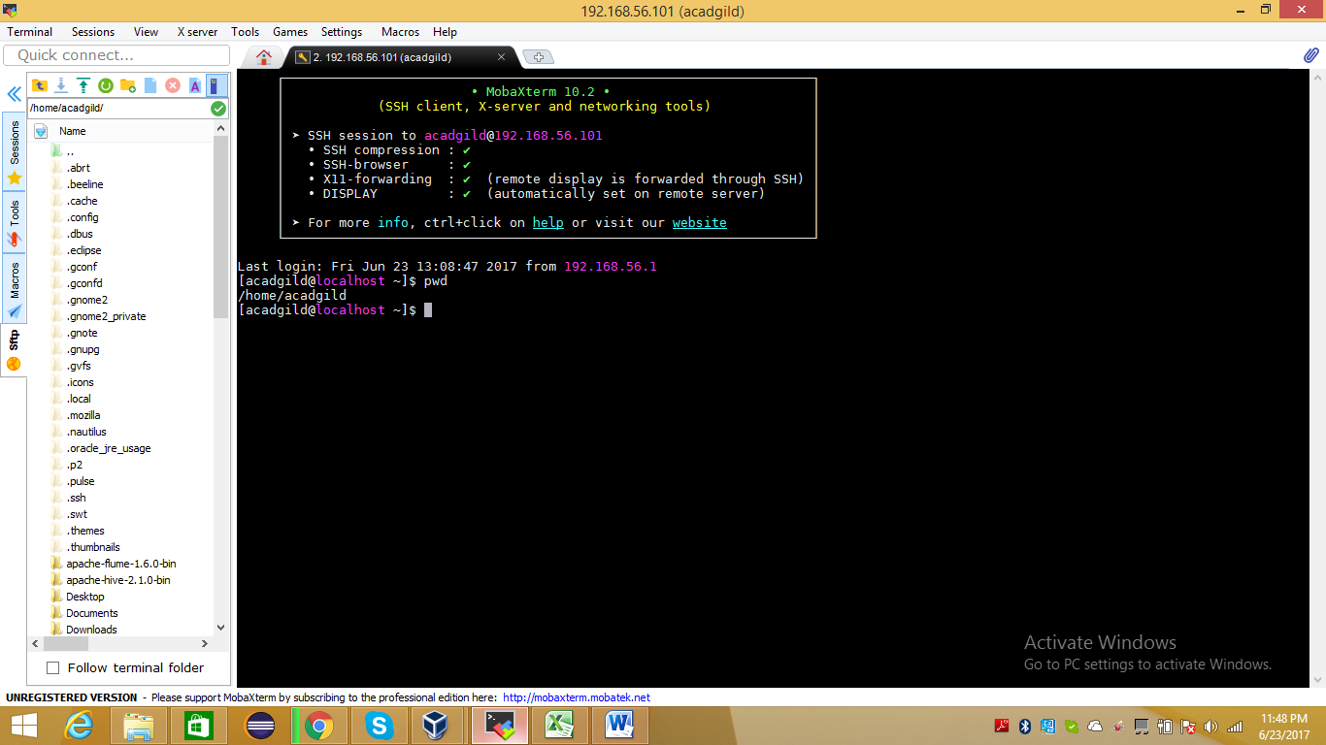

1. **vi:**

"Vi is command line text editor.there are two modes in VI editor insert mode and edit mode.in insert mode you may input or enter content into file.In edit mode you can move arround the file for performing actions delet text, copy text past text , searching text, replace text and saving etc.

for saving file use follwing commands:

1) ZZ (Note: capitals) - Save and exit

2) :q! - discard all changes, since the last save, and exit

3) :w - save file but don't exit

4) :wq - again, save and exit"

**Syntax: vi <filename>**

**Vi data.txt**

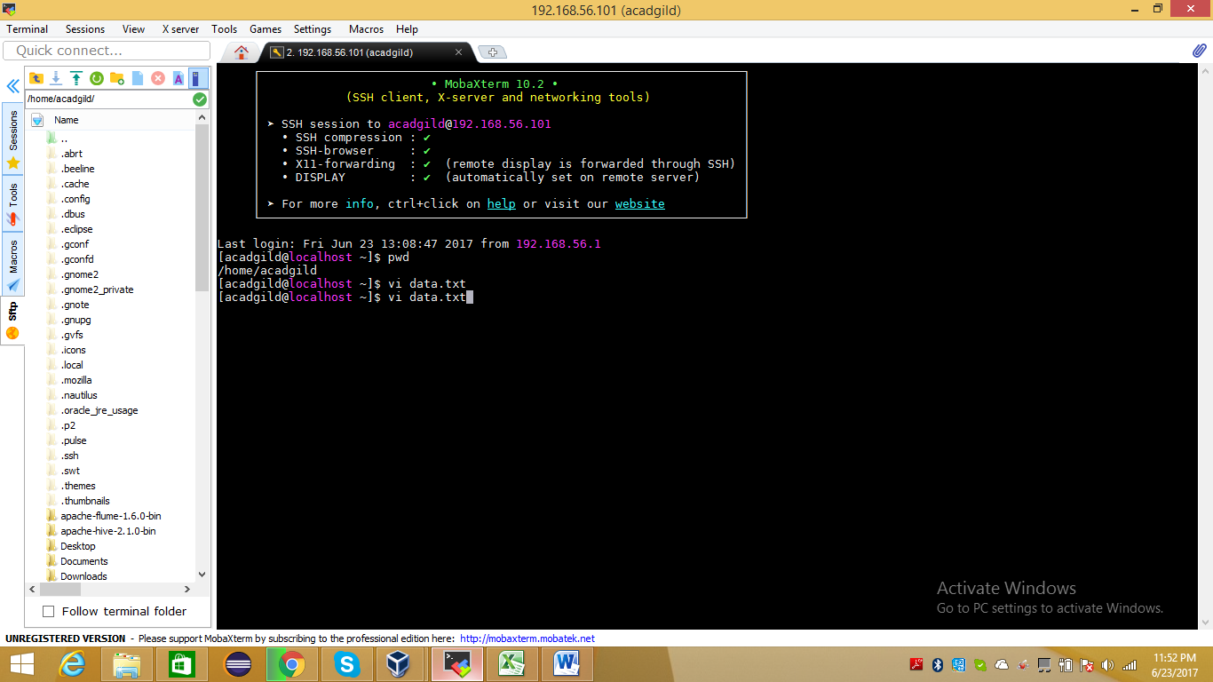

**Pressed enter button and added some data in file saved**

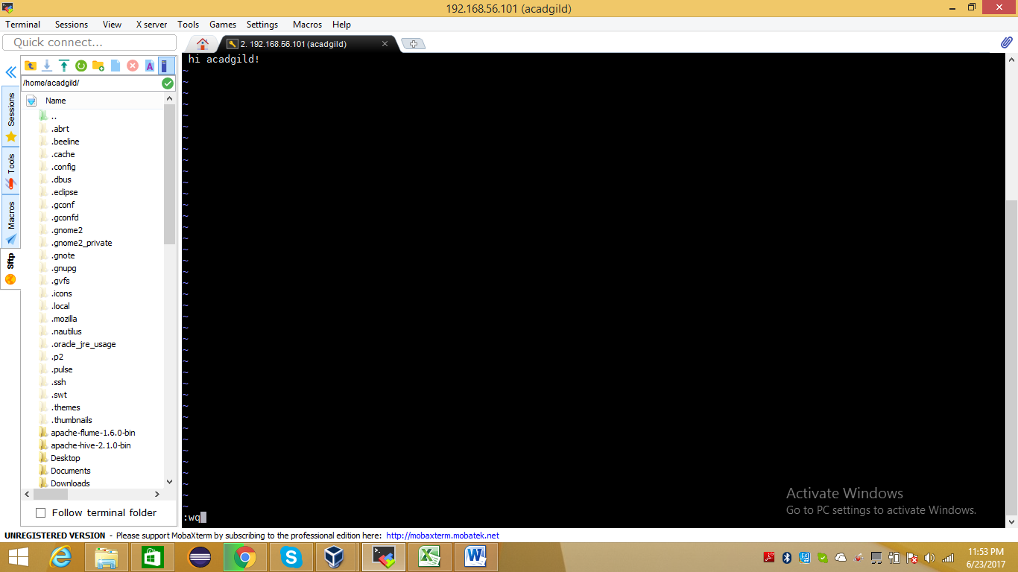

**3. touch**

touch command update the access and modification time of each file to current system time.

If you specify a FILE that does not exist, touch creates an empty fiie with that name .

Syntax :touch [OPTION]... FILE…

-a-> change only access time.

-c--no-create-> do not create file.

-d, --date=STRING -> Parse the string STRING and use it instead of current time.

-m ->Change only the modification time.

-r, ---.reference=FILE Use this FILE's times instead of current

Command: touch file.txt

File created by touch command and file is at top in below screen shot

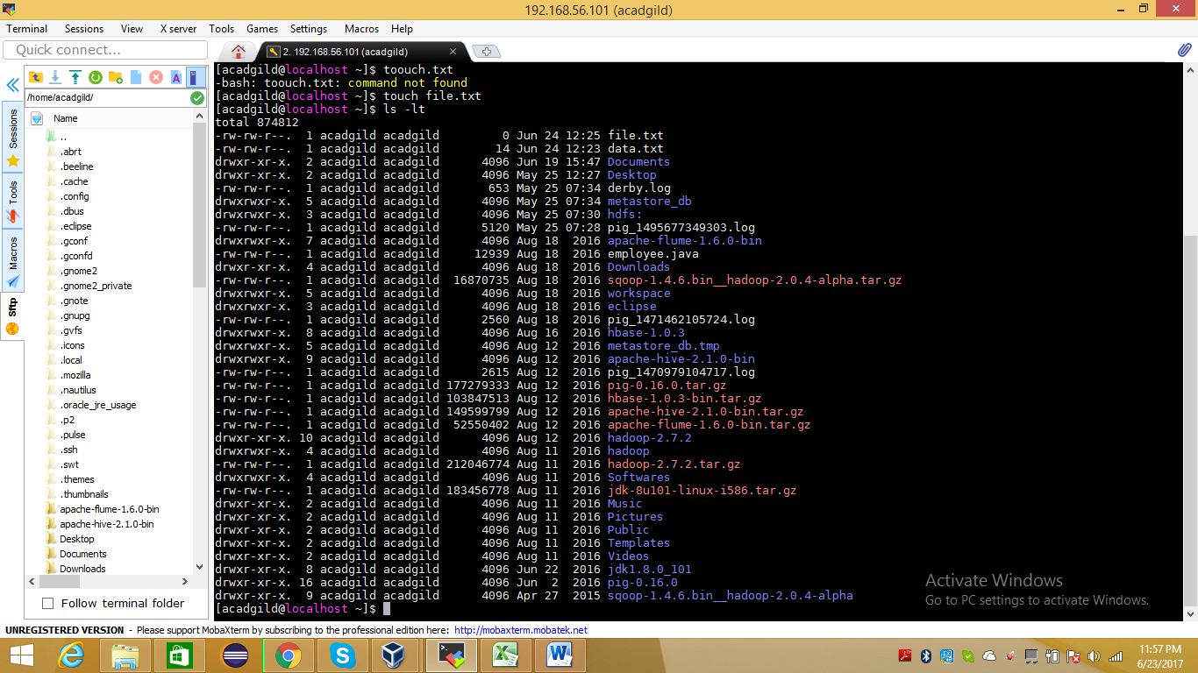

1. **mkdir**

This command is use to create new directories on file system.  
If the specified directory does not exist,mkdir creat it .  
Syntax :  
mkdir [OPTION ...] DIRECTORY …  
-m, --mode=MODE Set file mode (as with the chmod command).  
-p, --parents Create parent directories as necessary. When this option is used, no error is reported if a specified DIRECTORY already exists.  
-v -- verbos output msg, print msg for each created directory.

Command : mkdir -p home/acadgild/hadoop/user

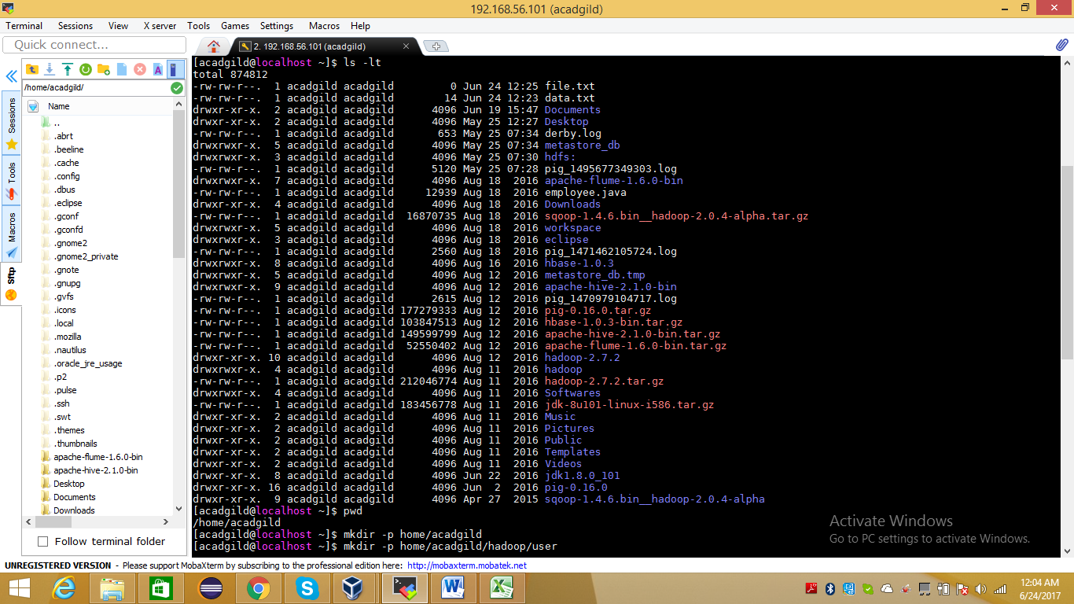

1. **rm**

rm command removes (deletes) directories or files.

rm syntax

rm [OPTION]... FILE…

-f, --force -> ignore non existence file and never prompt before removing.

-i -> prompt before every removal.

-I -> prompt before removing more than three files or when removing recursively, less itrrussive than -i,while sttill giving more protection against most mistakes.

-r,-R -> remove directoru=ies and their contents recursively.

Command : rm data.txt

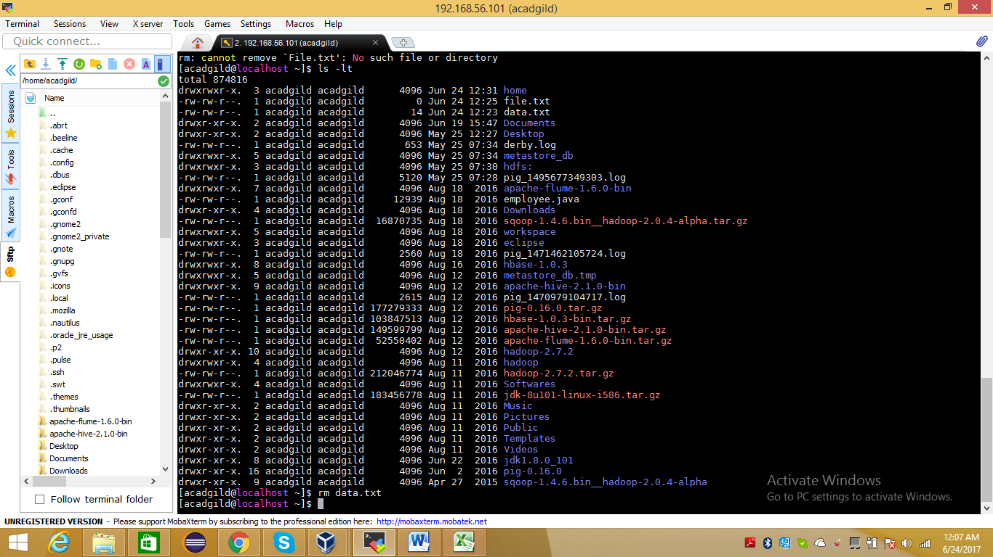

After command rm data.txt , the file has been removed local fs.pls refer below screen shot

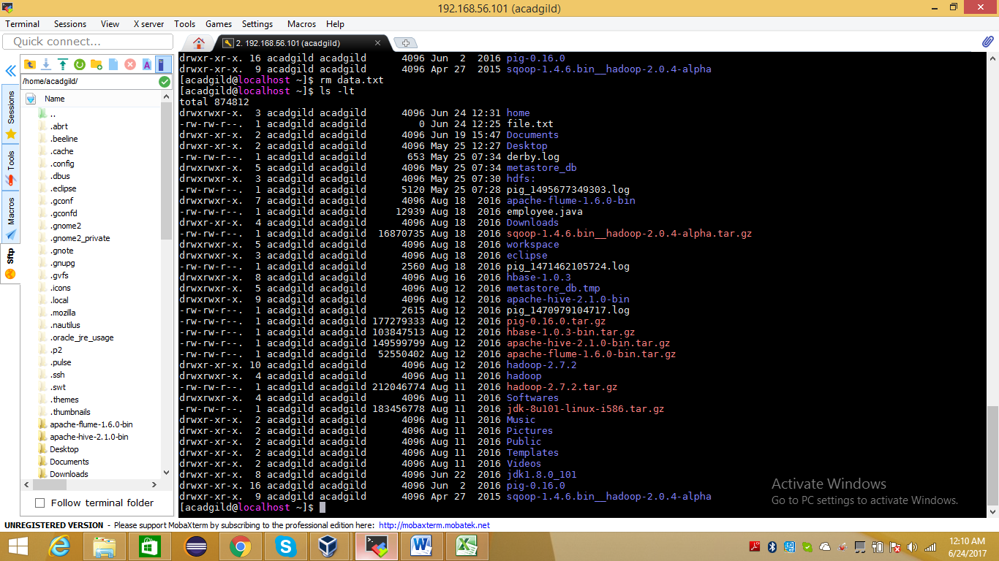

1. **ls**

list of content of directory.

syntax

ls [OPTION]... [FILE]…

command : ls

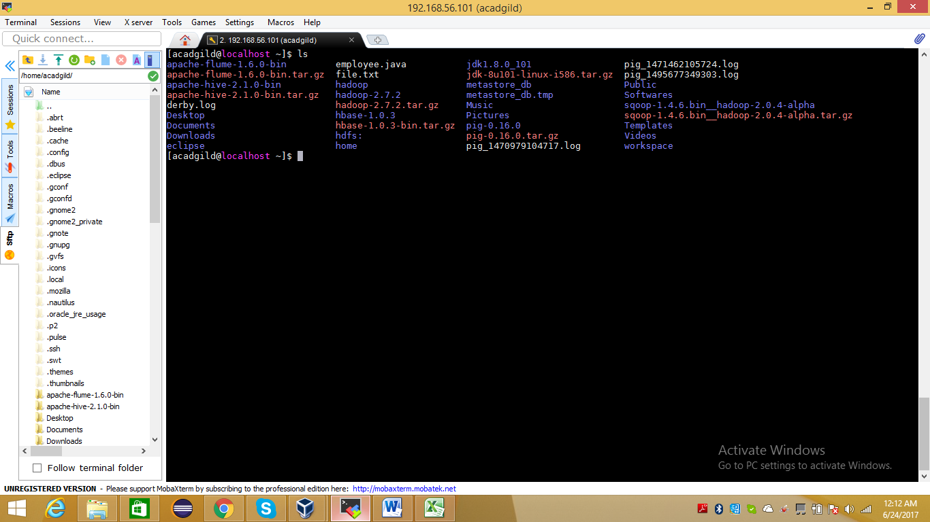

1. **echo:**

Displays the line of text.

Syntax :

echo [SHORT-OPTION/LONG OPTION]... [STRING]…

command : echo Hello, World!

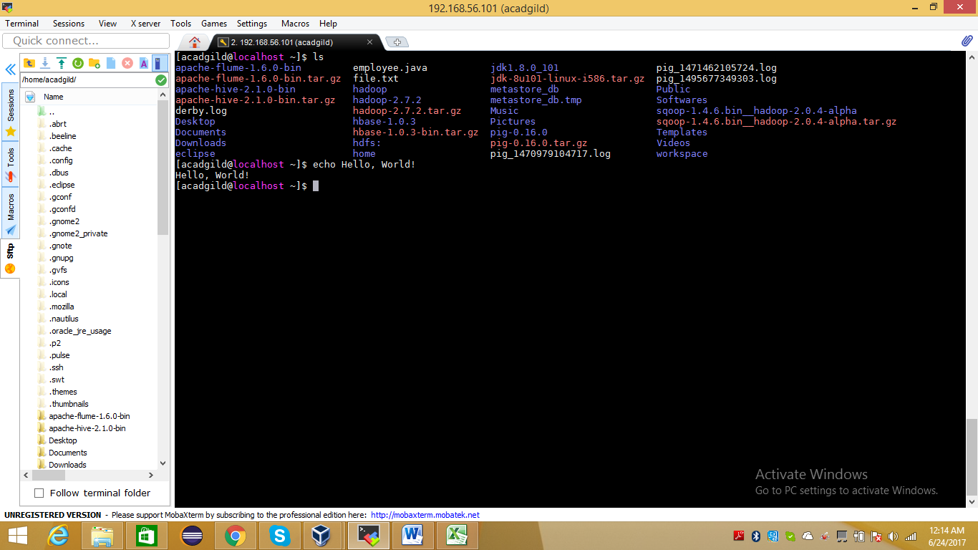

1. **cat**

cat stands for catenate.it reads data from files and output their contents. It is simplest way to display content of files.at is one of the most commonly-used commands in Linux. It can be used to Display text files Copy text files into a new document Append the contents of a text file to the end of another text file, combining them.

**Command:**  cat fle.txt

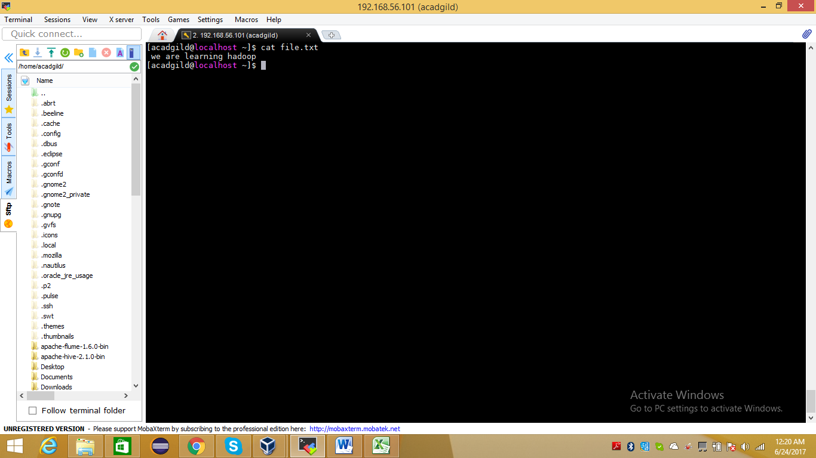

1. **who**

who logged on the system.the who commandprints information about users who are currently loggged in .

Syntax:

who [ OPTION ]... [ FILE ] [ am i ]

command: who

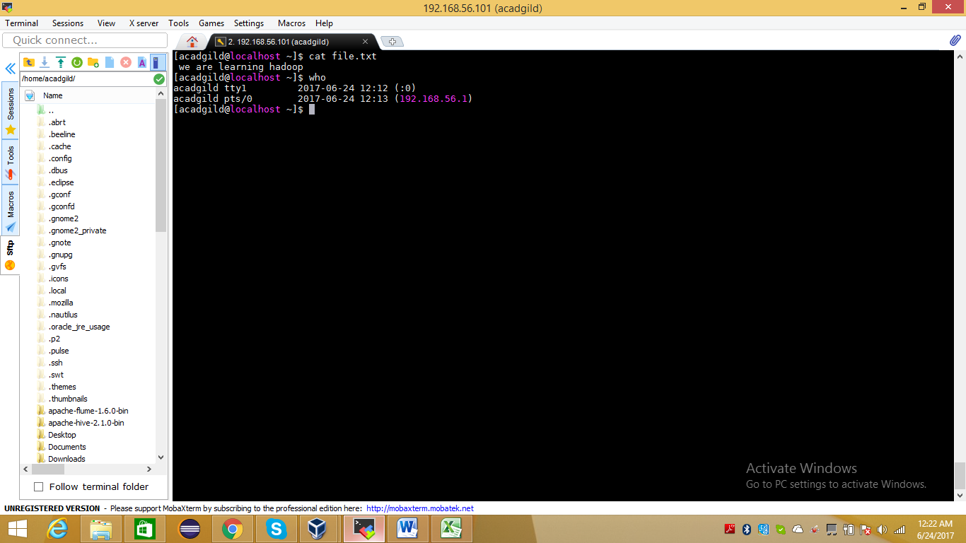

**10.cd:**

change the working directory

cd path-name

command cd hadoop

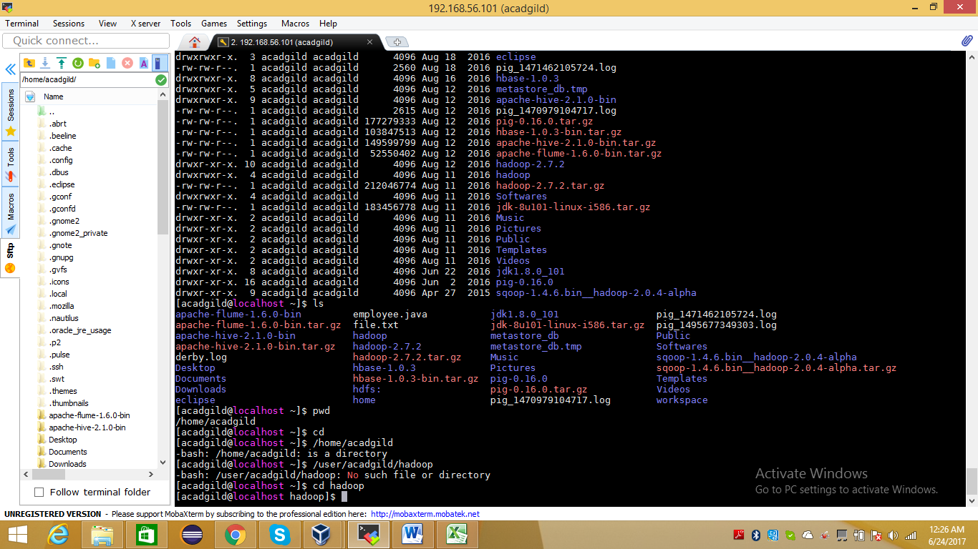

**11.date**

The date command is used to print out, or change the value of, the system's time and date information.

date syntax

date [OPTION]... [+FORMAT]

**command : date**

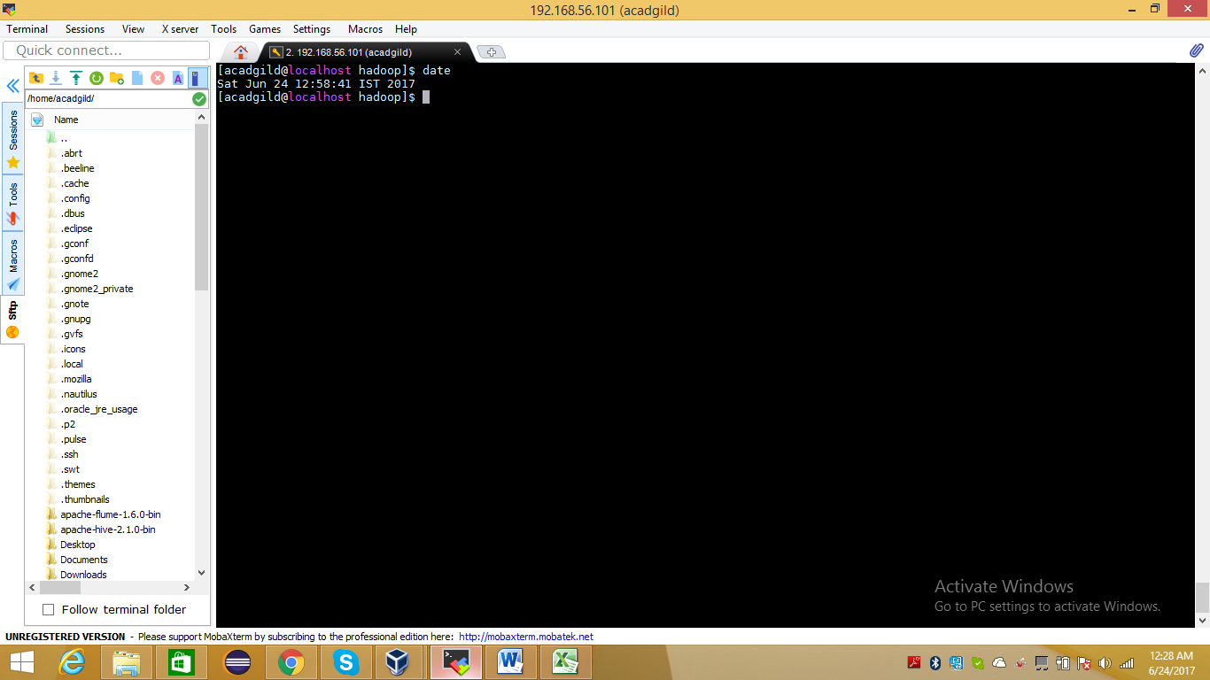

**12.cal**

Display the conventional formatted calender from command line

Syntax :

cal [options] [[[day] month] year]

-1 display sing month, which is default setting.

-3 display three months, last month, this month and next month.

-m display Monday as first day of the week.

-s dipslay calender using sunday as first day of week.

-j display date of julian calender.

-y Dipaly calender for entire year

Command : cal

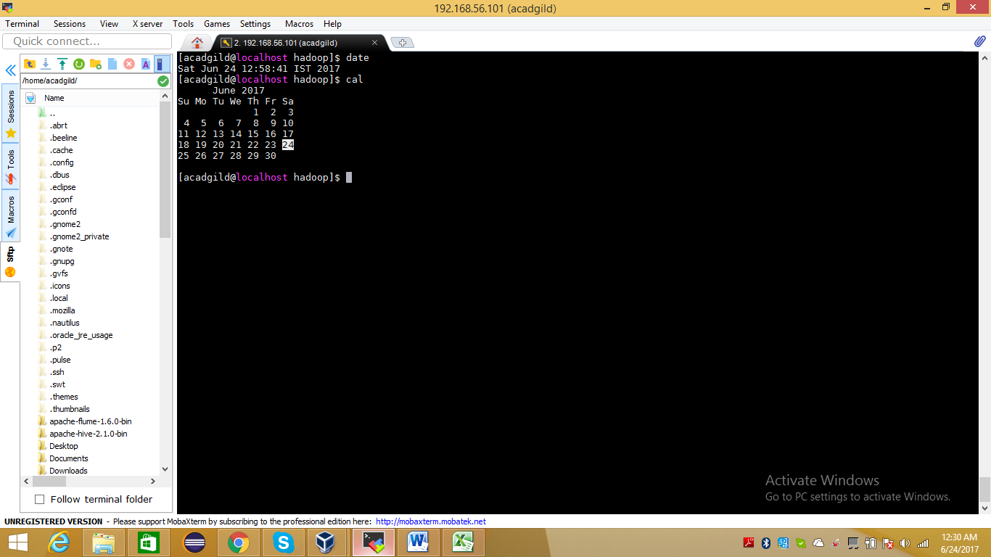

**13.mv**

mv command used to move or rename the file.

Syntax :

mv [OPTION]... [-T] SOURCE DEST

**command : mv file.txt file1.txt**

**file.txt renamed to fle1.txt**

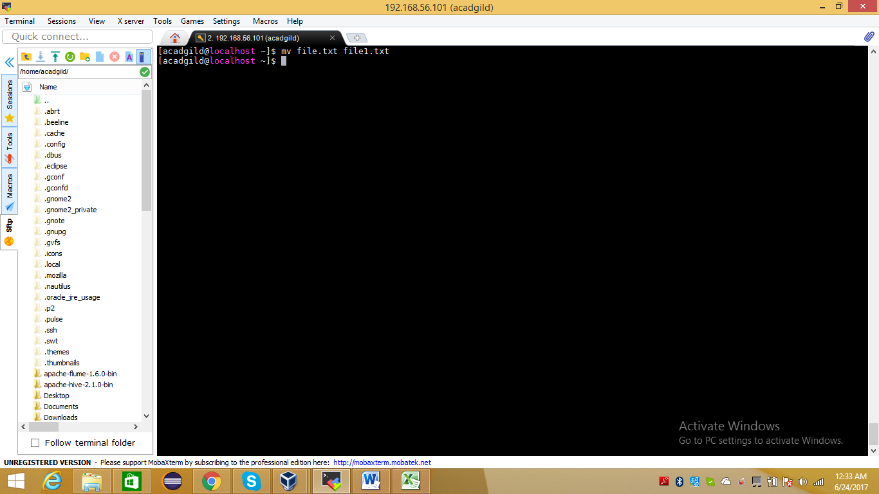

**14.cp**

cp commnad used to make coppies of files and directories.

cp [OPTION]... [-T] SOURCE DEST

command : cp file1.txt new.txt

copied content of file1.txt into new txt

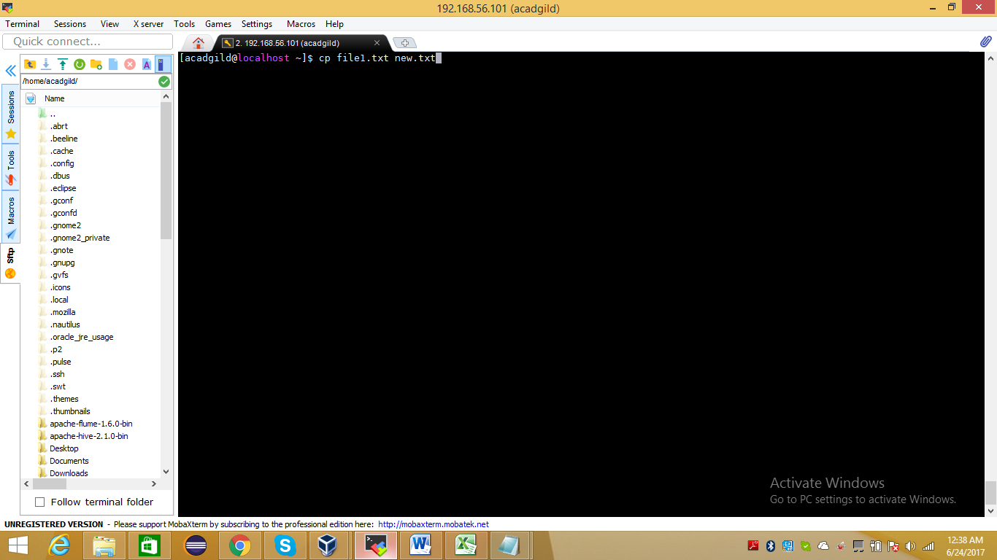

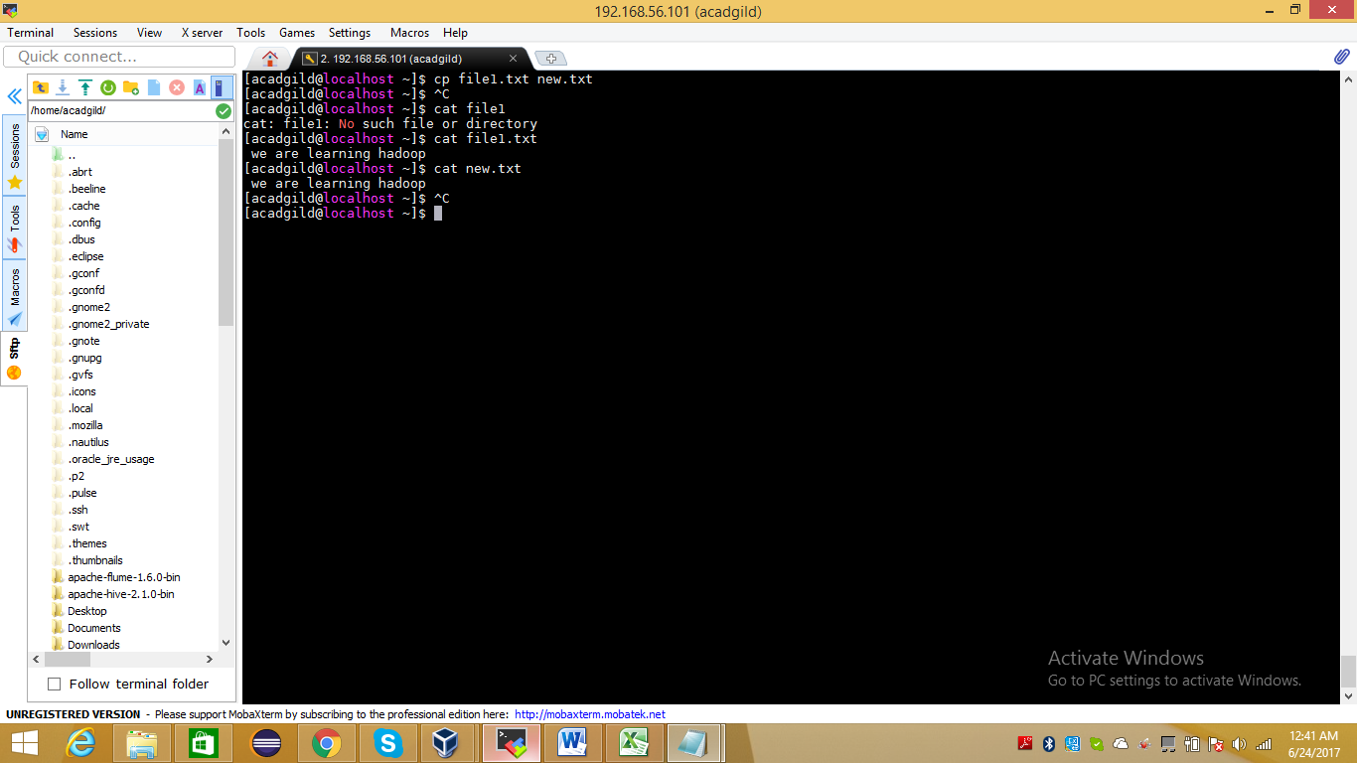

**15.which**

which returns path name of files which would be executed in current environment,had file name been given as a command in struxtly POSIX conforment shell.

Syntax:

which -a [filename] …

-a Print all matching pathnames of each matching filename.

Command : which sh

